**MINEX SUMMARY**

**Model 30-29-200-B 5C4 Chassis, Borosilicate Glass, Low Vibration Cryo Mount,**

**Capacitor Board and Beryllium Copper Traces**

**Vacuum Very Good Running in intermittent mode around 19watts (data recorded)**

**Cryo Very Good Cooldown to ColdHd 65K / LNA 73K, 213watts (data recorded)**

**X-pole Very Good Noise (4.5 – 3.5dB out to 14GHz)**

**Y-pole Very Good Noise (4.5 – 3.5dB out to 14GHz)**

**LNA RECOMMENDED BIAS SETTINGS**

**Vm + Vd must be set exactly to values below**

**Adjust Vg as needed to get Id 25.1 to 25.3**

|  |  |  |  |
| --- | --- | --- | --- |
| **Pole** | **Minex LNA S.N.** | **Bias at Minex** | **PAM’s (HC default)** |
| **X** | **C-0040a** | **Vm -.50v / Vg .38v / Vd 1.20v / Id 25.1ma** | **15.0 / 15.0** |
| **Y** | **C-0018a** | **Vm -.50v / Vg .03v / Vd 1.20v / Id 25.0ma** |

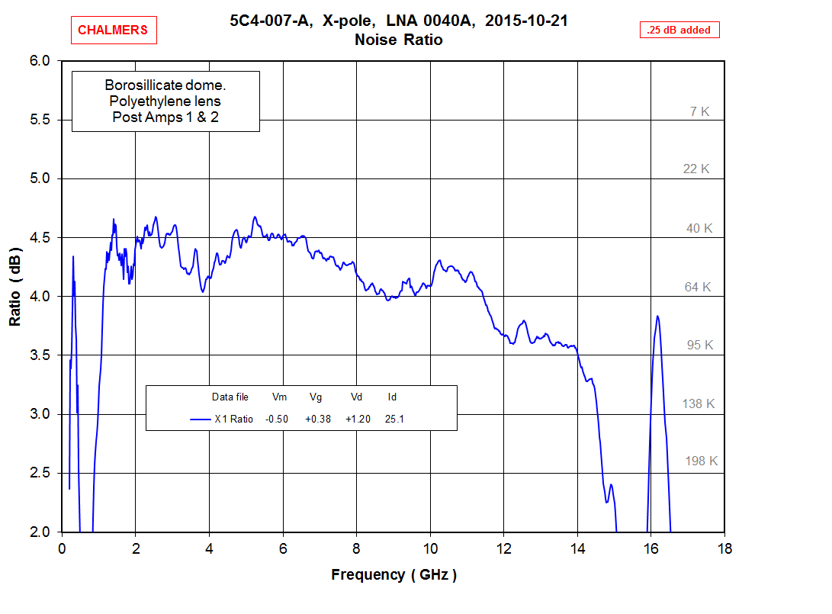

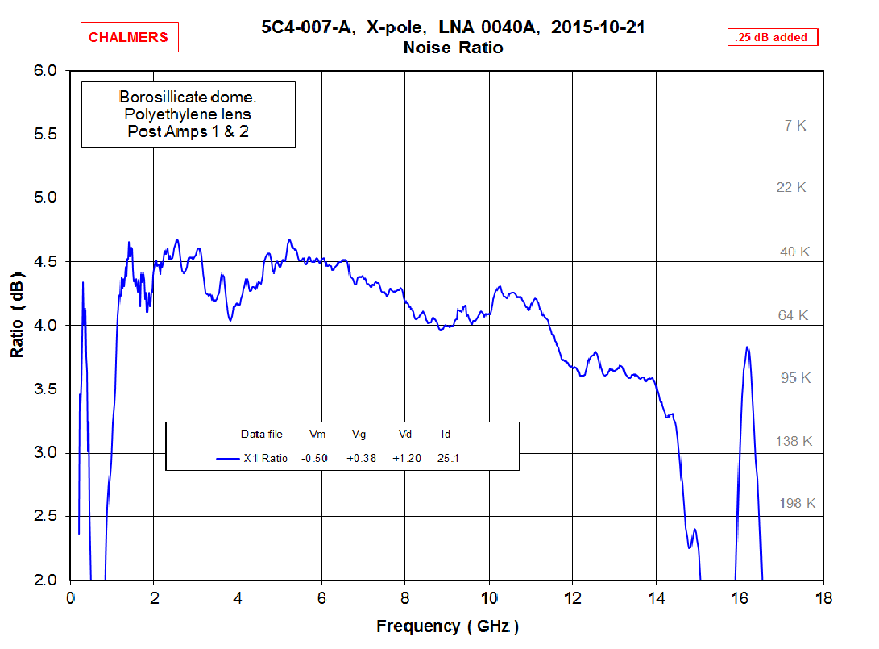

4.39” x 6.21”